|  |  |
| --- | --- |
|  |  |
| **Self-corrections:**   * Can you find the tricky part? * Are you right? * Take a closer look at ________________. * Could it be________________? * How did you know that word was?   **Visual:**   * Does it look right? * What sound/letter does it start with? * Put your finger under the word and say the different parts? * Read to the vowel.   **Structure:**   * Did that sound right? * Can you reread that? * Can you say it another way? * What is another word that might fit here?   **Meaning:**   * Did that make sense? * Look at the pictures. * What happened in the story when _____? * What do you think it might be? * Can you reread this? | |

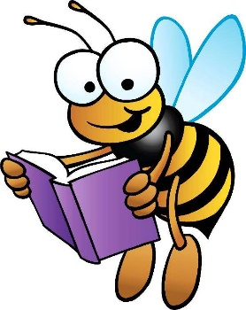

Reading Prompts

to help your child while reading.